1. The build should trigger as soon as anyone in the dev team checks in code to master branch.

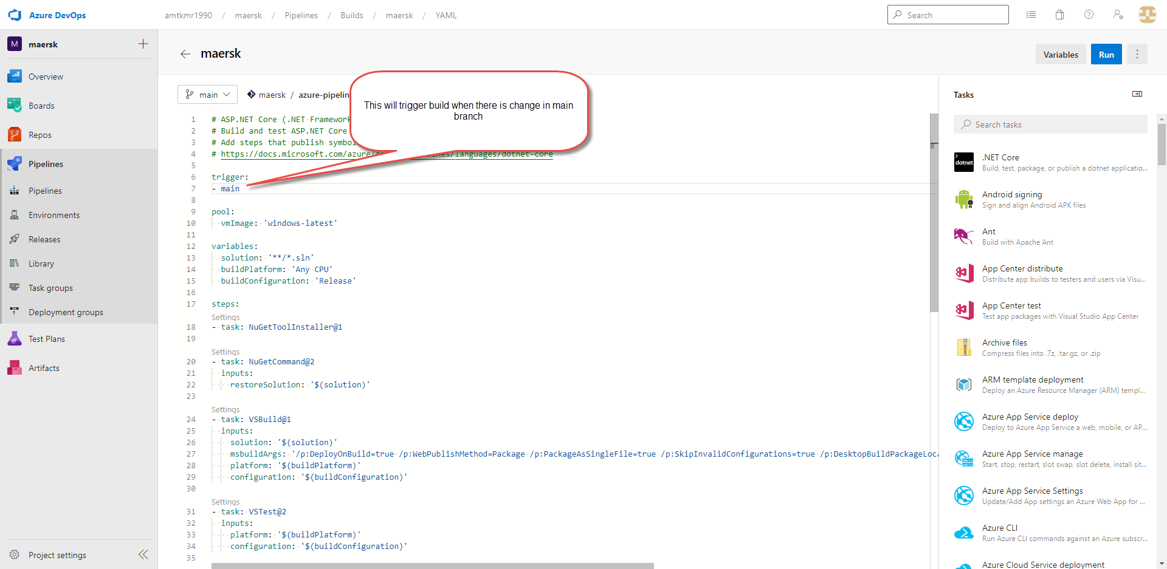

2) There will be test projects which will create and maintained in the solution along the Web and API. The trigger should build all the 3 projects - Web, API and test.

The build should not be successful if any test fails.

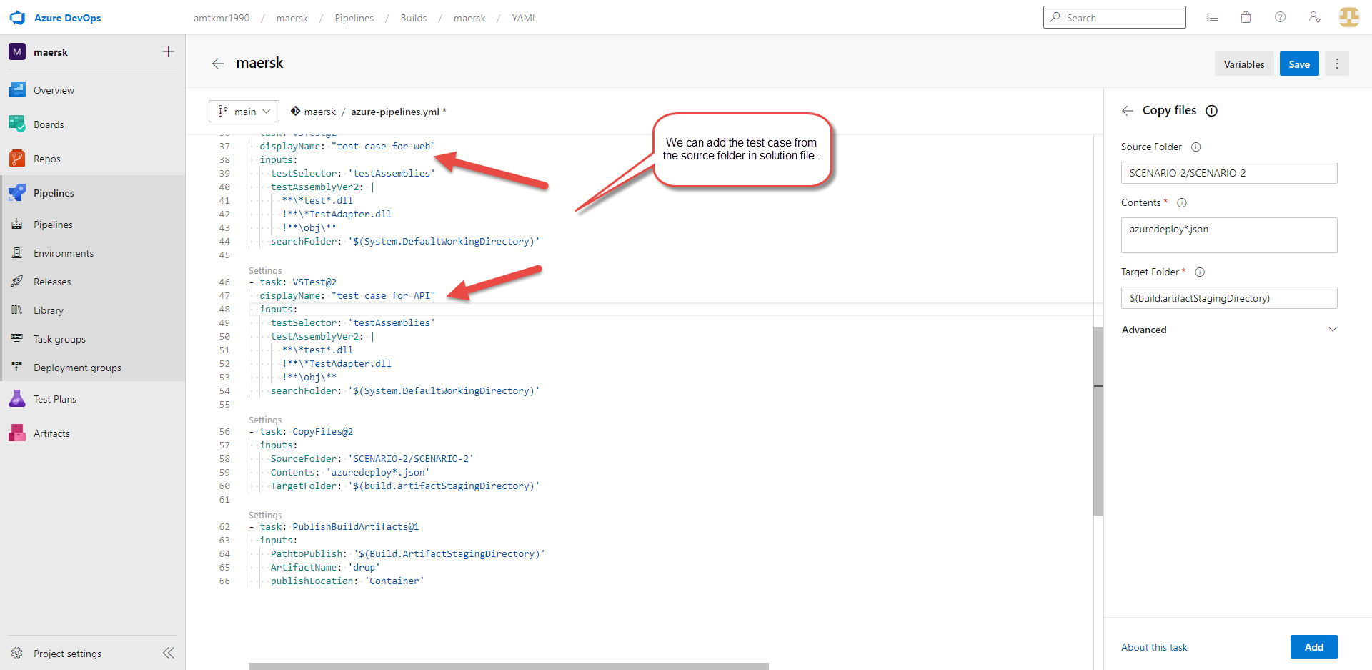

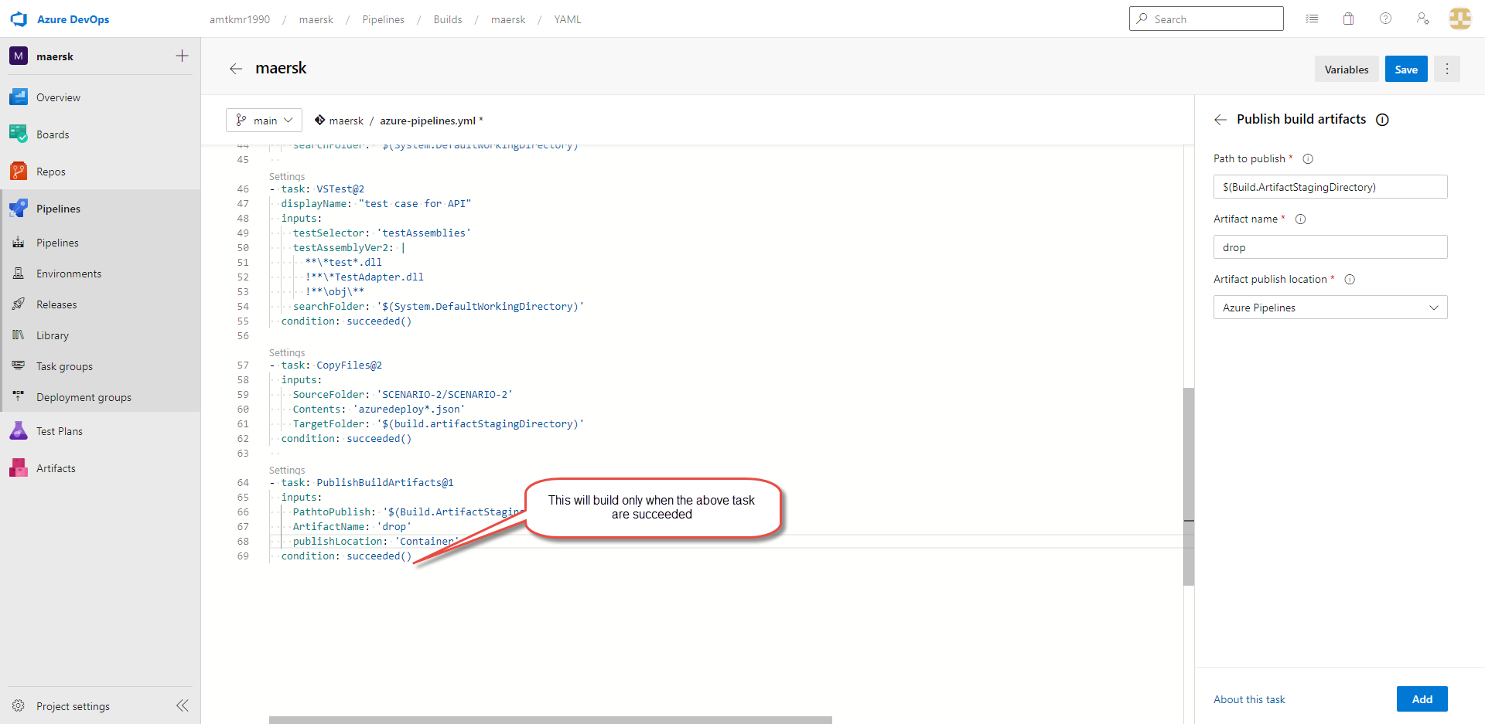

1. The deployment of code and artifacts should be automated to Dev environment.

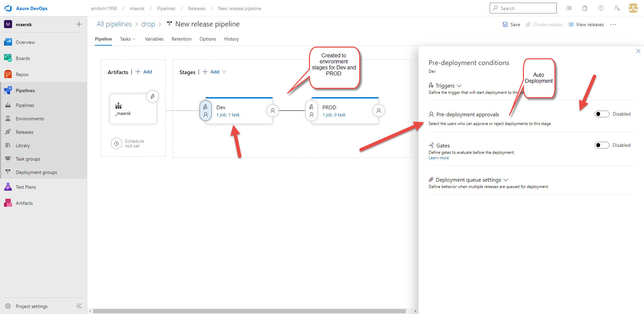

1. Upon successful deployment to the Dev environment, deployment should be easily promoted to QA and Prod through automated process.

5) The deployments to QA and Prod should be enabled with Approvals from approvers only.

